Raritan Valley Community College

English Composition II (ENGL 112-21)

Professor: Lisa Tucker

October 2nd, 2024

Project #2 (finaldraft)

Miguel Angel Martinez Serrato, Nathanael Kaphan, Jose Reyes Herrera

**Non-profit Organizations in the American Living**

There is a tremendous crisis on how much living costs. People around the globe are worried about their respective economies due to several issues such as war or internal or external politics. In the United States economy is not working as well as should work. With the highest inflation in 40 years and interest rates going high, more people are worrying about how they will pay their bills or how to buy food. Most people are obligated to seek help from others. While people usually worry for themselves, several organizations nationwide are helping those without having something in change.

**United Way**

*By Miguel Angel Martinez Serrato*

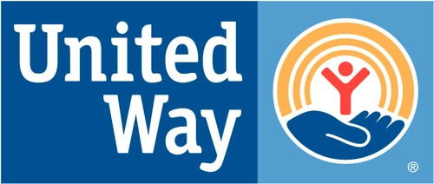

To begin, there are several Non-profit organizations around the United States which help those needed people on the most needed communities. To mention one, there is the example of United Way.

United Way is a national well-known non-profit organization which mission is to build resilient communities where everyone has equity of possibilities. This Non-profit organization served more than 95% of the US communities and helped another 37 countries and territories around the globe helping a total of 48 million people every year. They have several focuses to achieve strong communities. But talking about this topic, financial stability is one of the goals they have for communities. To achieve it, they connect people and families to several services such as helping to fill in the tax forms for free and offer any other resources to consequently help them to cover their basic needs, and to get better stability and hence, contribute to the community.

**Fish Inc.**

*By Jose Reyes Herrera*

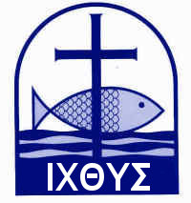

Secondly, these national non-profit organizations have several issues related to the network to arrive to every single community nationwide. That is because there are several local non-profit organizations which help their respective communities. In New Jersey there are several non-profit organizations which main goal is to help those who are affronting problems to fulfill their needs. One of these receives the name of The Fish and is located in Dunellen, NJ.

This non-profit organization begin in 1961 with a group of people in St. Andrew's church in oxford, England. which mission is to help others who have any need. To do so, a street warden distributes on all oxford houses "Fish cards". The function of these is to tell the street warden who will need help by looking at the fish card at the windows of the oxford inhabitants.

The history of the fish in the United States begin from Rev. Robert L. Howell which founded the group after a regular meeting in 1964 at Springfield, MA. based on the idea of the Oxford group. Since there, The Fish has been spread nationwide until the arrival to our area.

Their mission is to help poor, elderly and homeless people, and also people who "fail between the cracks" of public assistance. This branch of The Fish helps those who need assistance in a great part of Somerset and Middlesex counties.

The name comes from a bible lecture which says:

*Along the shores of the Sea of Galilee Jesus came*

*upon two brothers, Peter and Andrew, and said to*

*them: "Follow me and I will make you*  *fishers of*

*men." Since that time many people have been*

*trying to follow Christ as fishers of men. Some*

*people have succeeded in doing this through Fish.*

*Matthew 4, 18-22*

Then, continuing with national non-profit organizations, we have the example of Habitat for Humanity.

**Habitat for Humanity**

*By Nathanael Kaphan*

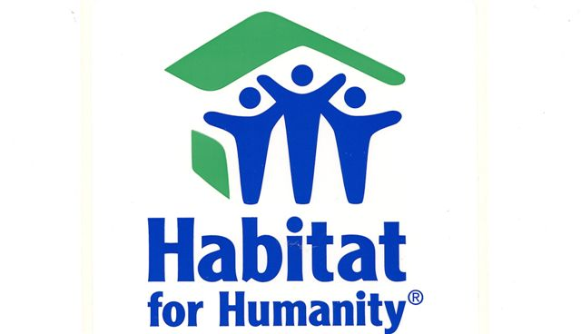

Habitat for Humanity is a Christion non-profit organization founded by Clarence Jordan Millard at the outskirts of Atlanta, GA whereby they work to develop the “partnership housing” concept. That concept was born from the need for a good shelter with help from volunteers to build affordable housing. This organization also helps with house repairment in low-income communities to make them livable and comfortable. In other words, Habitat for Humanity creates new construction, renovates existing homes, and improves and repairs homeowner’s current properties. Their principles rely on demonstrating the Love of Jesus Christ, focusing on shelter, advocating for affordable housing, promoting dignity and hope, and supporting sustainable and transformative development. They partner with the local communities in the area they are trying to help create or improve the place others call home.

Habitat for Humanity works on all the American union and about 70 countries and territory giving a quality shelter to all who need it. They also help relieve strees for those for those who worry about the cost of living. They allow those in poor situations to improve their life while also contributing, putting in “sweat equity”, to the help they are receiving. Which heightens their sense of homeownership and pride. Habitat for Humanity is constantly looking to help others and is constantly needing help making a great opportunity to serve others and provide shelter.

In Conclusion. There are several Non-profit organizations which goal is to help people fulfil their basic needs in a successful way by helping to get food or having free resources to redo their lives or giving a little push to people who have needs. There are other organizations around the US or even around the globe, but these two are examples of companies that only want to help in a disinterested way. Corporations and people around world are also taking conscience about the importance of these non-profit organizations to the point that they donate part of their income to these organizations to help people to improve their communities. After talking about this topic, there is only one question to ask ourselves. Will we contribute to these organizations?